**Setting For Update & Delete Query operation in MySQL Workbench**

**Step 1:** Click on Edit, Click on Preferences

Click on SQL Editor

Scroll Down

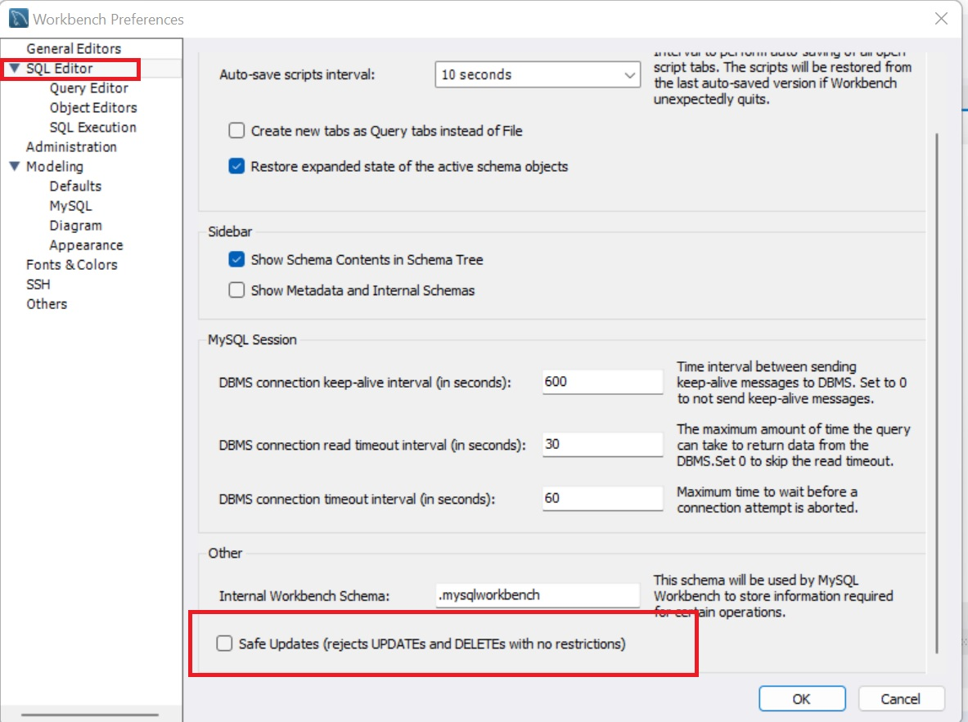

Uncheck the checkbox of Safe Updates

Click on OK button

**Note:**

Restart MySQL Workbench

Then Update and Delete queries successfully executed